Water WS/Calorimetry
Online tutorial: http://www.kentchemistry.com/links/Matter/HeatingCurve.htm
Watch and refresh—Heat of Fusion, Specific Heat and Heat of Vaporization
Use your knowledge to answer the following questions

Values for water
solid (ice) 2.03 | Heat of vaporization 2260 J/g
liquid 4.18 | Normal boiling point 100⁰C
gas (steam) 2.01 | Normal freezing point 0⁰C
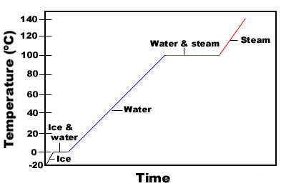
Insert the formulas on the graph for each step of the warming curve. Include q=mc∆t for each state of matter and specific heat values.

Also include formulas for each phase change and the associated constants.

Label each phase change.
1. How many joules are needed to heat 200. g of water from 40.0 ºC to 90 ºC ?

2. How many joules are needed to melt 200g of ice at 0 ºC?

3. How many joules are needed to change 100g of ice at -20 ºC to water at 60 ºC?

4. How many joules needed to be removed to change 150g of steam at 100 ºC to water at 100 ºC?

5. How many joules need to be removed to change 150 g of steam at 110 ºC to water at 70.
0 ºC?

6. Calculate the specific heat capacity of copper given that 204.75 J of energy raises the temperature of 15g of copper from 25º to 60º.

7. 216 J of energy is required to raise the temperature of aluminum from 15º to 35ºC. Calculate the mass of aluminum.
(Specific Heat Capacity of aluminum is 0.90 JºC⁻¹g⁻¹).

8. The initial temperature of 150g of ethanol was 22ºC. What will be the final temperature of the ethanol if 3240 J was needed to raise the temperature of the ethanol?
(Specific heat capacity of ethanol is 2.44 JºC⁻¹g⁻¹).

9. How many kilojoules of heat are absorbed when 1.00 L of water is heated from 18°C to 85°C? (Hint: You first need to determine the mass of the water, then calculate q in the requested unit.)

10. A piece of aluminum with a mass of 100.0 g has a temperature of 20.0°C. It absorbs 1100 J of heat energy. What is the final temperature of the metal?

11. An unknown metal has a mass of 18.0 g. If the temperature of the metal sample rises from 15.0°C to 40.0°C as the sample absorbs 89.0 J of heat, what is the specific heat of the sample? Now look at your periodic table and choose a metal that is most likely the identity of the sample.

